**Map Comparison**

We have taken three cases (insertion Element, Accessing Element and Searching Element) for both the Maps i.e., Ordered Map(Tree Map) and Unordered Map(Hash map). And in all three, we have generated a graphical representation of the execution time as the number of points keep on increasing in both the cases.

And we deduce few Observations mention below:

Case 1 (Inserting Element): While inserting element in Unordered Map, we are getting constant time in more than 90% of our points. But in case of Ordered Map, as the number of points increasing, the time taking to insert the element increases. This shows that in ordered map, it’s taking some extra time to find the sorted position for the element.

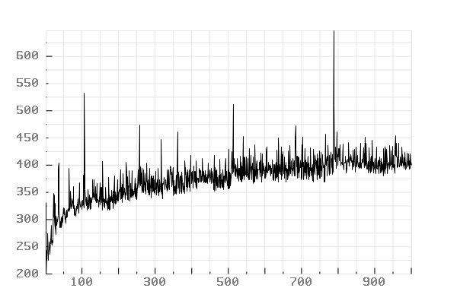

Ordered map taking more time when points are more

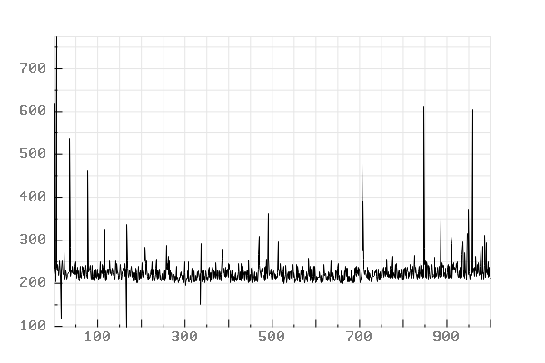

Unordered map taking less time when points are more since no sorting

Case 2 (Accessing Element): While Accessing Element, in both cases, we are getting similar behaviour and it’s taking mostly constant time. If there are any changes in the observation, that’s only cause of the system architecture or how the operating system handles operation control i.e., if there are multiple operation going on in the system then the operation for accessing the element may get into the state of starvation.

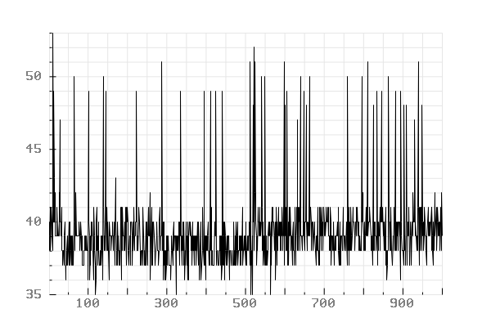

Unordered map taking constant time to access the data

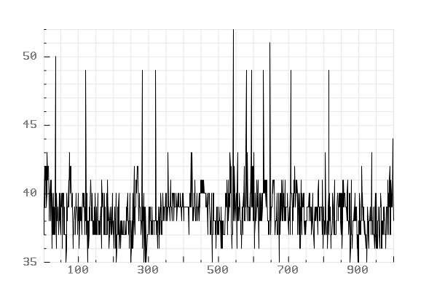

Ordered map taking constant time to access the data

Case 3(Searching Element): While Searching Element in Ordered Map, we Observed that it is taking very less time and it’s obvious as it is sorted. Whereas in Unordered Map, the time taken in searching any element is very high since in a worse case it has to iterate all the element. And hence the size of the map increases, the time taken to search the element is also increase respectively.

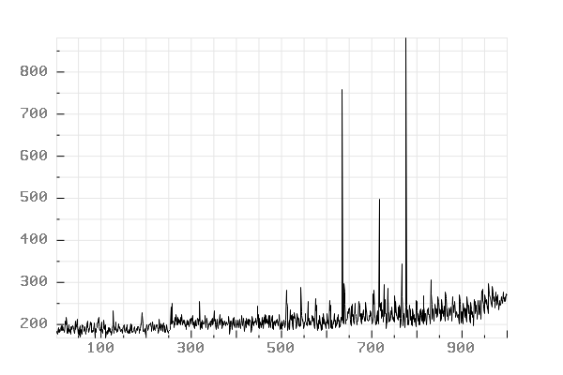

Ordered map taking less time to search the element since the map is sorted

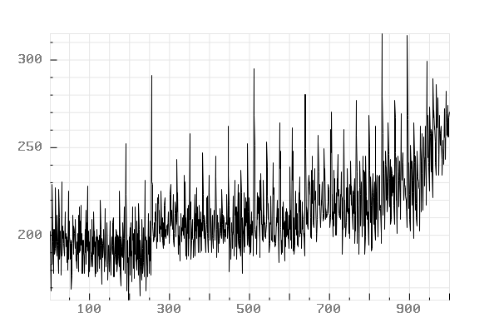

Unordered map taking more time since the element are inserted in random ordered